# Efficient Frontier Investment Analysis

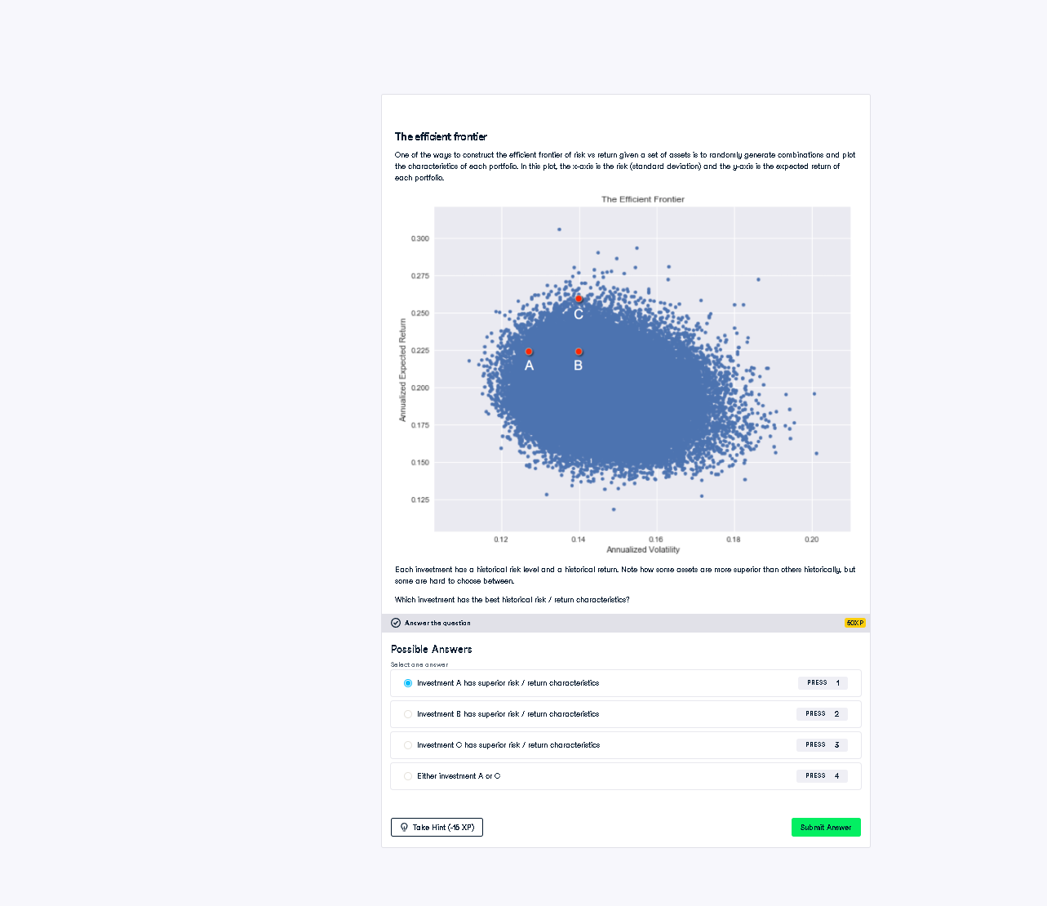

## Python Reasoning / Financial Analysis

No Python code is needed for this visual question. But here’s the reasoning based on financial analysis:  
  
We assess investments A, B, and C by comparing their return (Y-axis) to their risk/volatility (X-axis):  
  
- Investment C has the highest return and only a slightly higher risk than A or B.  
- The risk-return ratio (return ÷ risk) is best for C, meaning C lies closest to the efficient frontier.  
  
✅ Correct answer: Investment C has superior risk/return characteristics

## Explanation in Simple Words

We choose the investment that gives the most return for the least risk. On the graph, Investment C is higher up (better return) and not much further right (risk) than A or B.  
So, it gives better reward for each unit of risk. That's why C is the best choice.